|  |  |  |  |
| --- | --- | --- | --- |
| **CALL ALL** | |  |  | | --- | --- | | **MAP** | **1** | |
| **Hillside Road Otahuhu** | Printed 1/1/2014 |

**Do not call. Camp Rd 30**

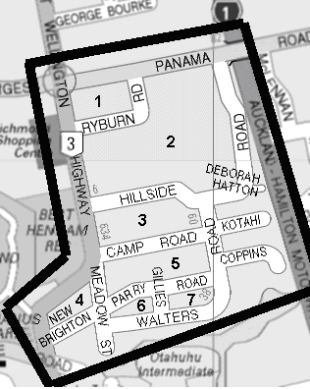

|  |  |  |  |
| --- | --- | --- | --- |
| **CALL ALL** | |  |  | | --- | --- | | **MAP** | **2** | |
| **Luke St Otahuhu** | Printed 1/1/2014 |

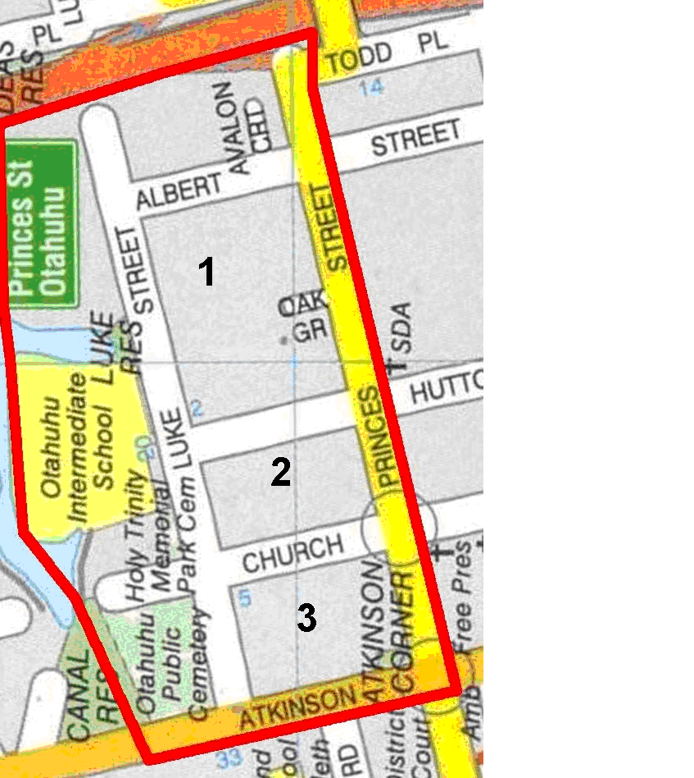

|  |  |  |  |
| --- | --- | --- | --- |
| **CALL ALL** | |  |  | | --- | --- | | **MAP** | **3** | |
| **Huia Road Otahuhu** | Printed 1/1/2014 |

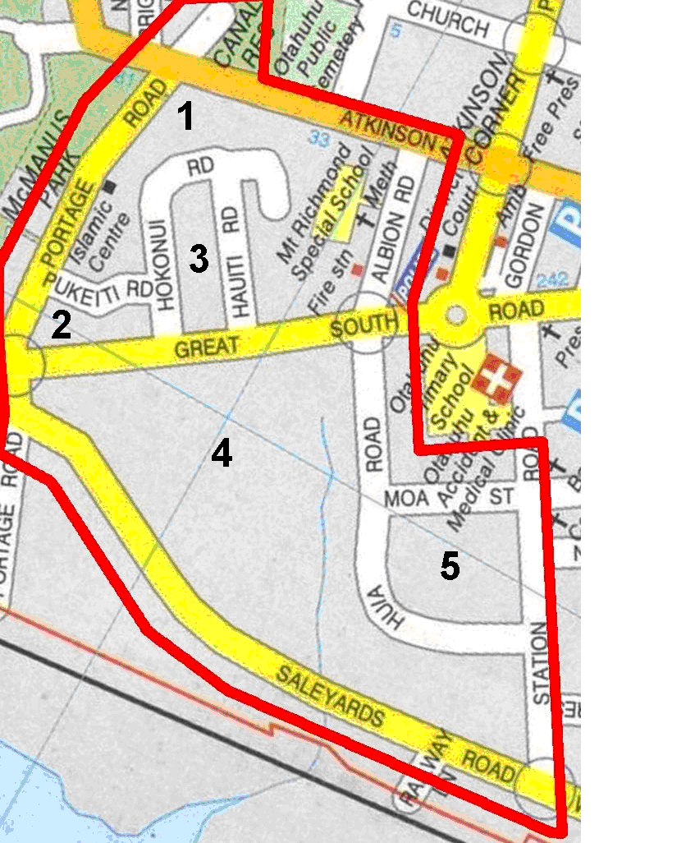

|  |  |  |  |
| --- | --- | --- | --- |
| **CALL ALL** | |  |  | | --- | --- | | **MAP** | **4** | |
| **Avenue Road Otahuhu** | Printed 1/1/2014 |

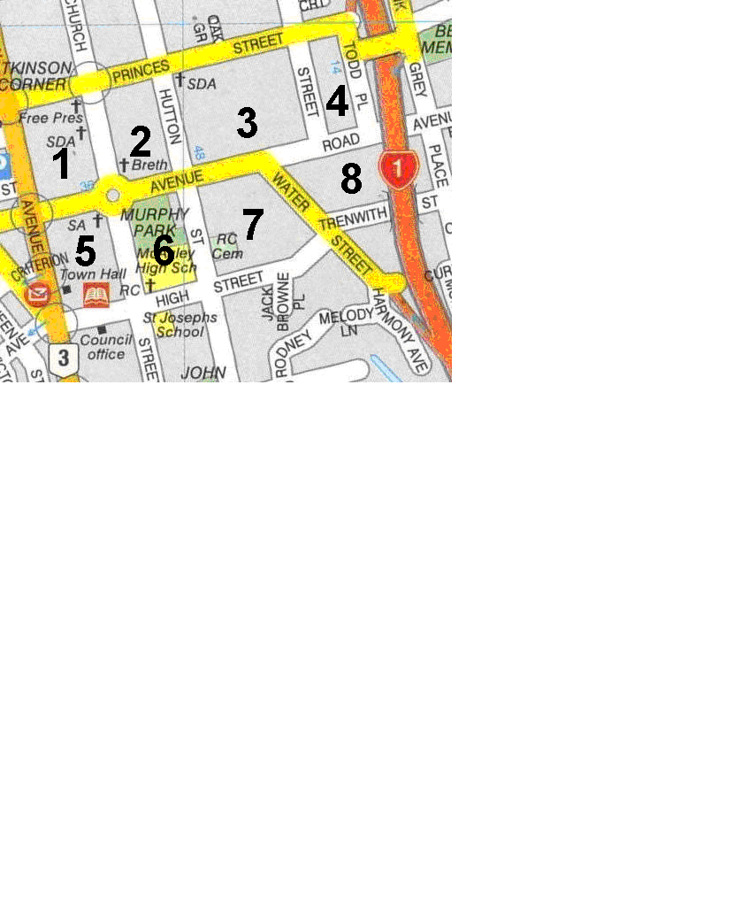

|  |  |  |  |
| --- | --- | --- | --- |
| **CALL ALL** | |  |  | | --- | --- | | **MAP** | **5** | |
| **Fairburn Road Otahuhu** | Printed 1/1/2014 |

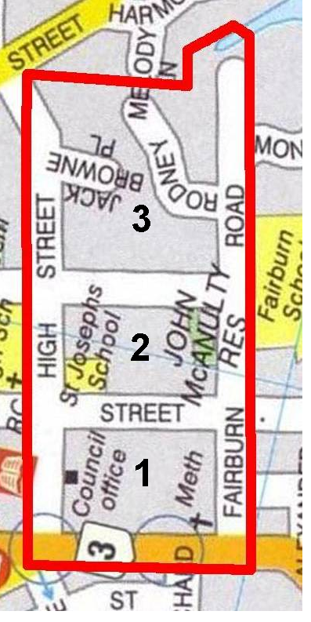

|  |  |  |  |
| --- | --- | --- | --- |
| **CALL ALL** | |  |  | | --- | --- | | **MAP** | **6** | |
| **Nixon Avenue Otahuhu** | Printed 1/1/2014 |

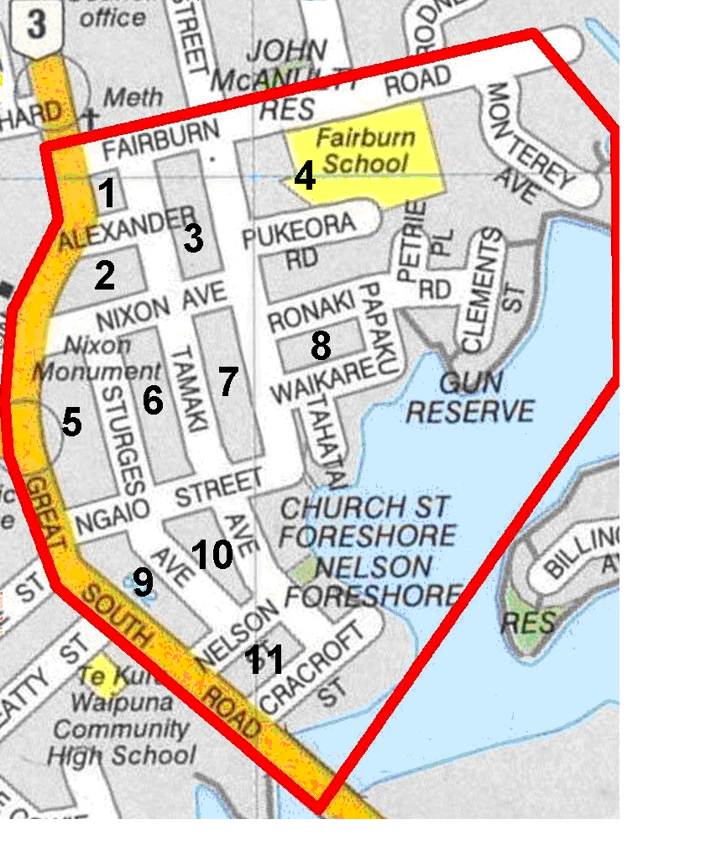

|  |  |  |  |
| --- | --- | --- | --- |
| **CALL ALL** | |  |  | | --- | --- | | **MAP** | **7** | |
| **Wymondley Road** | Printed 1/1/2014 |

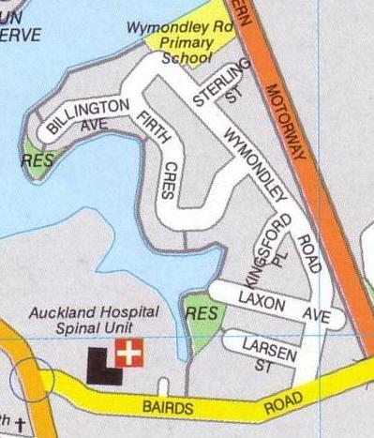

|  |  |  |  |
| --- | --- | --- | --- |
| **CALL ALL** | |  |  | | --- | --- | | **MAP** | **8** | |
| **Walmsley Road Otahuhu** | Printed 1/1/2014 |

**Do not call Nikau 10**

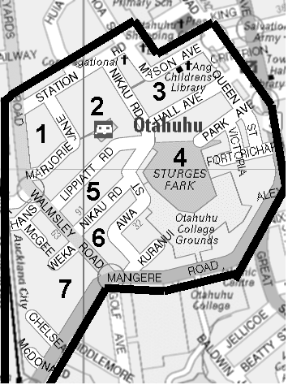

|  |  |  |  |
| --- | --- | --- | --- |
| **CALL ALL** | |  |  | | --- | --- | | **MAP** | **10** | |
| **Ferndown Avenue Papatoetoe** | Printed 1/1//2014 |

**Do not calls Misty 8**

**Carringbah 28 Chantelle 26**

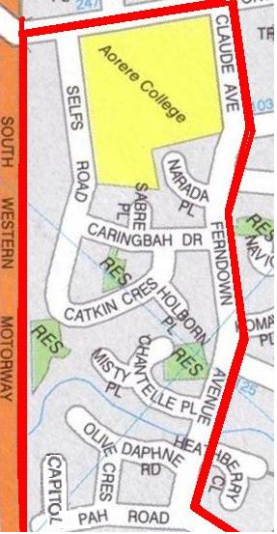

|  |  |  |  |
| --- | --- | --- | --- |
| **CALL ALL** | |  |  | | --- | --- | | **MAP** | **11** | |
| **Grange Road Papatoetoe** | Printed 1/1/2014 |

Do not call

Grange 11 and 19

Great South Road 65a and 769 and 775

Lansdown 5 (halfway house)

McCullough 2 and 25 and 27

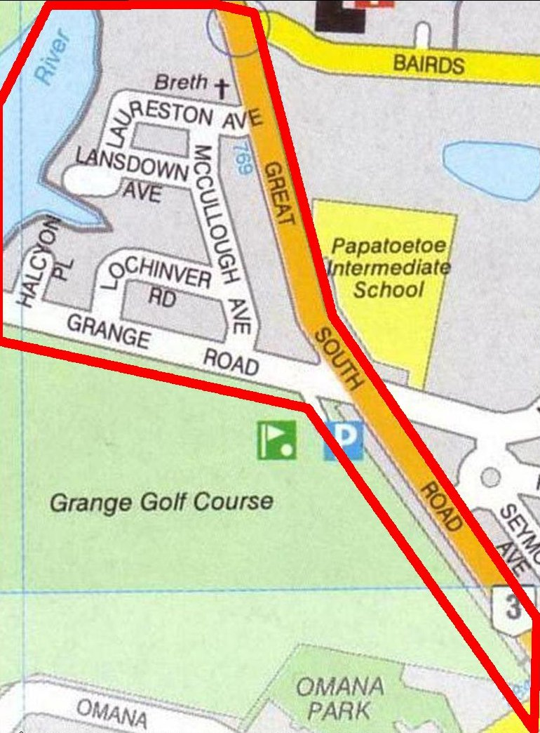

|  |  |  |  |
| --- | --- | --- | --- |
| **CALL ALL** | |  |  | | --- | --- | | **MAP** | **12** | |
| **Motatau Road Papatoetoe** | Printed 1/1/2014 |

Do not Calls

Motatau Road 30 and 35 and 106 and 127

Pukeko 8a and 8b Kautami 66

Seymour Ave 24 Kakapo 29a

Sunnyside 14 and 17 and 27 and 36

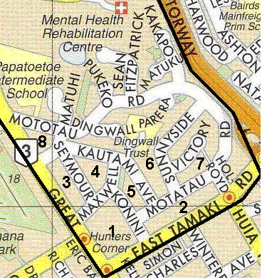

|  |  |  |  |
| --- | --- | --- | --- |
| **CALL ALL** | |  |  | | --- | --- | | **MAP** | **13** | |
| **Vine Road Mangere** | Printed 1/1/2014 |

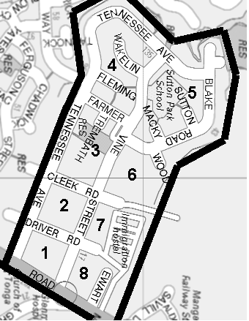

|  |  |  |  |
| --- | --- | --- | --- |
| **CALL ALL** | |  |  | | --- | --- | | **MAP** | **14** | |
| **Favona Road Mangere** | Printed 1/1/2014 |

Do not Call Favona 85

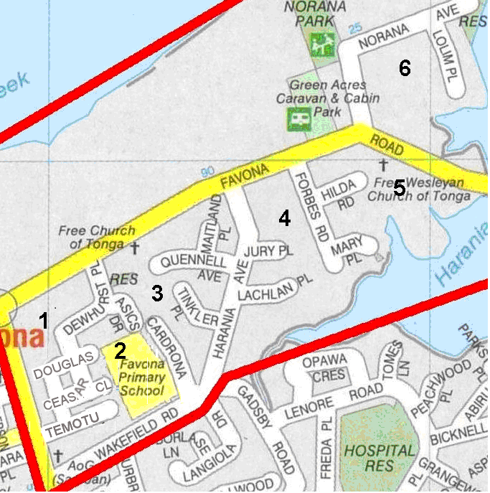

|  |  |  |  |
| --- | --- | --- | --- |
| **CALL ALL** | |  |  | | --- | --- | | **MAP** | **15** | |
| **Gadsby Road Mangere** | Printed 1/1/2014 |

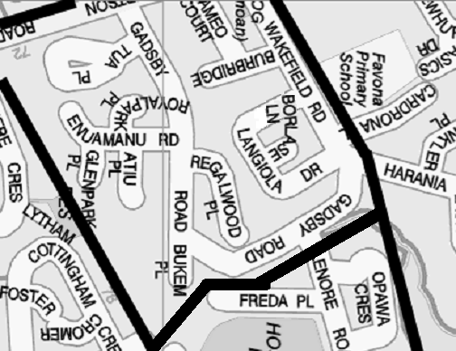

|  |  |  |  |
| --- | --- | --- | --- |
| **CALL ALL** | |  |  | | --- | --- | | **MAP** | **16** | |
| **McKinstry Avenue Mangere** | Printed 1/1/2014 |

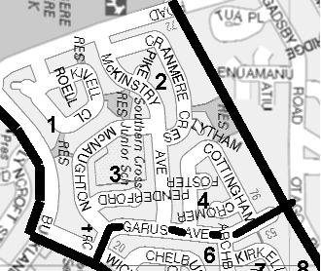

|  |  |  |  |
| --- | --- | --- | --- |
| **CALL ALL** | |  |  | | --- | --- | | **MAP** | **17** | |
| **Yates Road Mangere** | Printed 1/1/2013 |

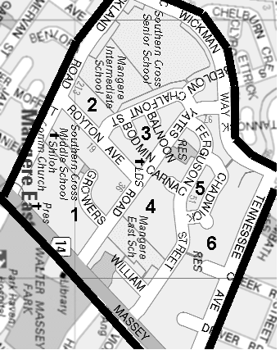

|  |  |  |  |
| --- | --- | --- | --- |
| **CALL ALL** | |  |  | | --- | --- | | **MAP** | **18** | |
| **Ashley Avenue Mangere** | Printed 1/1/2014 |

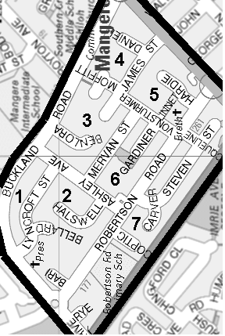

|  |  |  |  |
| --- | --- | --- | --- |
| **CALL ALL** | |  |  | | --- | --- | | **MAP** | **19** | |
| **Mahunga Drive Mangere** | Printed 1/1/2014 |

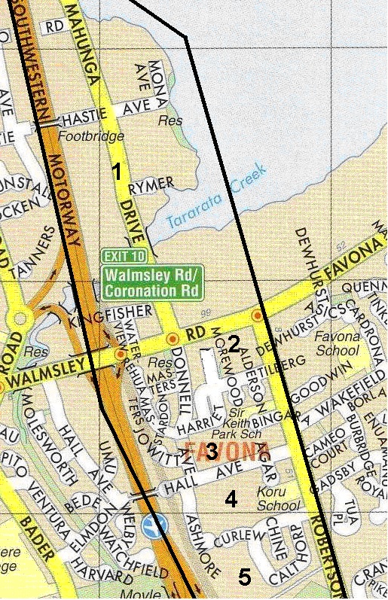

|  |  |  |  |
| --- | --- | --- | --- |
| **CALL ALL** | |  |  | | --- | --- | | **MAP** | **20** | |
| **Omana Road Papatoetoe** | Printed 1/1/2014 |

**Do not Call**

**Cambourne 11**

**Trimmer 22**

**Omana 22/1**

**Shirley Rd 182/1**

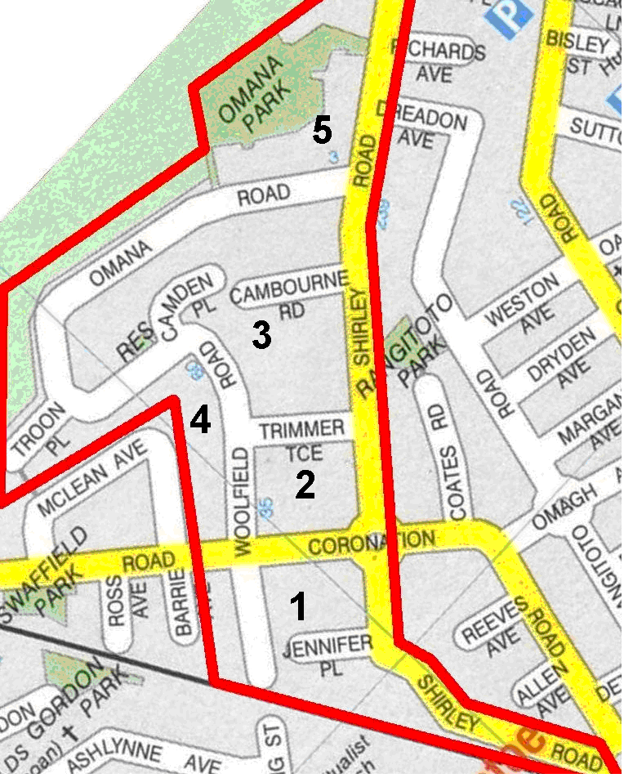

|  |  |  |  |
| --- | --- | --- | --- |
| **CALL ALL** | |  |  | | --- | --- | | **MAP** | **21** | |
| **Swaffield Road Papatoetoe** | Printed 1/1/2014 |

**Do Not Call**

**Barrie 16**

**McLean 28 and 35 and 42 and 54**

**Middlemore crescent 7c and 42 and 73**

**Swaffield Crescent 44/2**

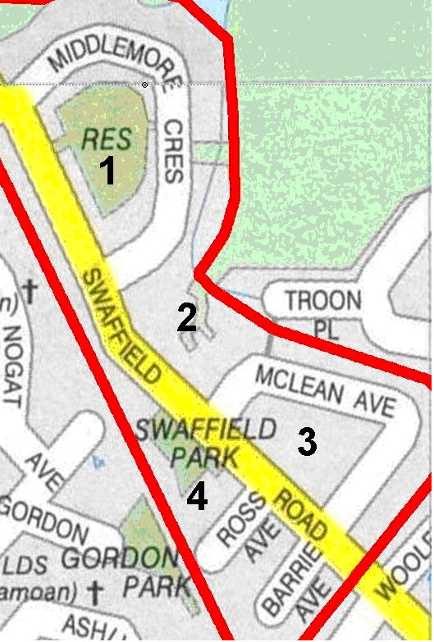

|  |  |  |  |
| --- | --- | --- | --- |
| **CALL ALL** | |  |  | | --- | --- | | **MAP** | **22** | |
| **Coronation Road Papatoetoe** | Printed 1/1/2014 |

**Do not call**

**Allen 50 Coronation Road 75/1 and 79**

**Reeves 11/1 Shirley Road 209/1 and 283**

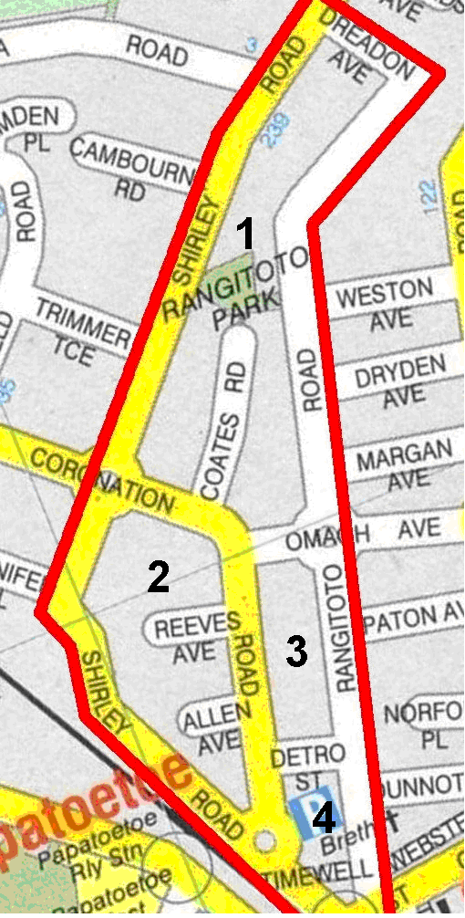

|  |  |  |  |
| --- | --- | --- | --- |
| **CALL ALL** | |  |  | | --- | --- | | **MAP** | **23** | |
| **Kolmar Road Papatoetoe** | Printed 1/1/2014 |

Do not Call

Weston 13 Omagh 31/3

Rangitoto 101 Dryden 22

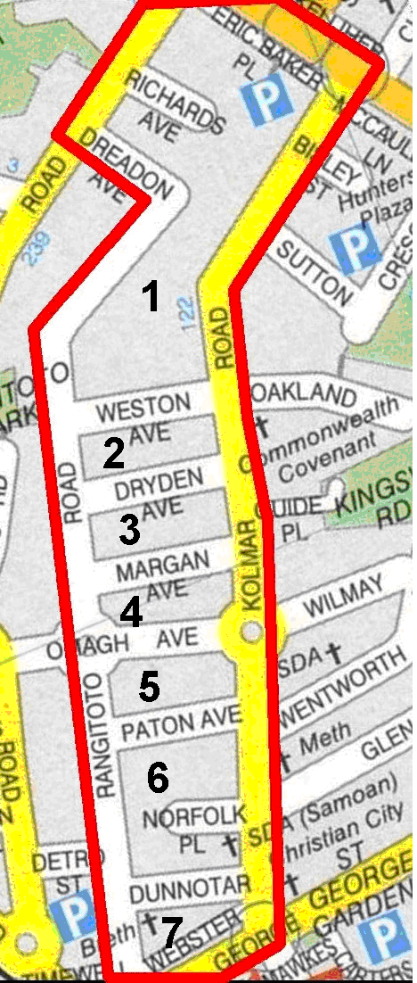

|  |  |  |  |
| --- | --- | --- | --- |
| **CALL ALL** | |  |  | | --- | --- | | **MAP** | **24** | |
| **Rosella Road Papatoetoe** | Printed 1/1/2014 |

**Do not call Miami 17**

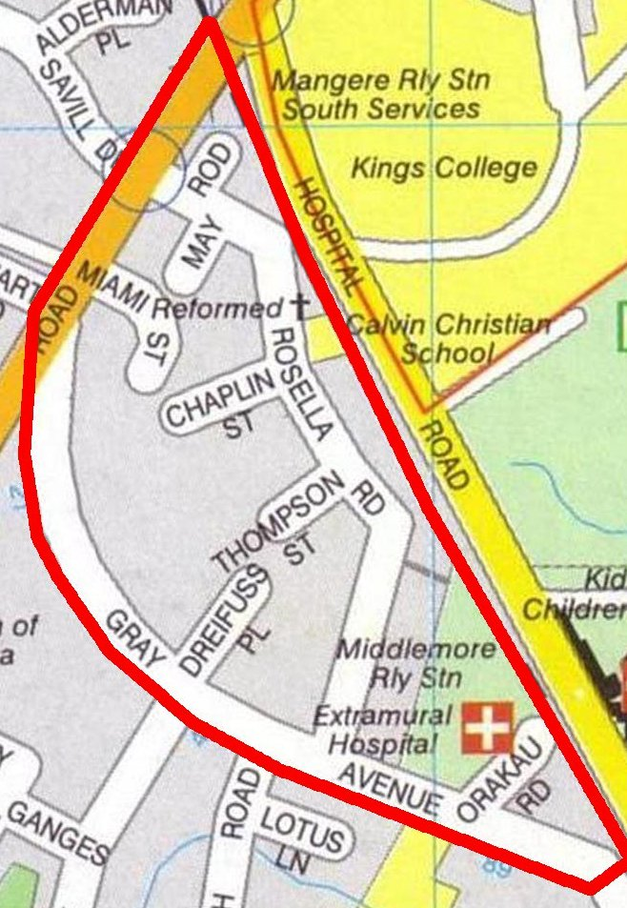

|  |  |  |  |
| --- | --- | --- | --- |
| **CALL ALL** | |  |  | | --- | --- | | **MAP** | **25** | |
| **Hain Avenue Papatoetoe** | Printed 1/1/2014 |

**Do not Call**

**Buckland 47 and 81 Gray Avenue 19a**

**Hallberry 64 Malcolm 4**

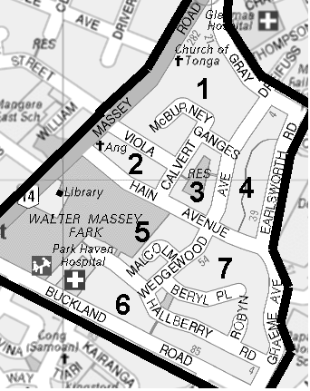

|  |  |  |  |
| --- | --- | --- | --- |
| **CALL ALL** | |  |  | | --- | --- | | **MAP** | **26** | |
| **Station Road Papatoetoe** | Printed 1/1/2014 |

**Do not Call**

**Ashlynne 24 and 24a Gordon 9**

**Peverill 18 Station Rd 70**

**Portage Extension 34/3**

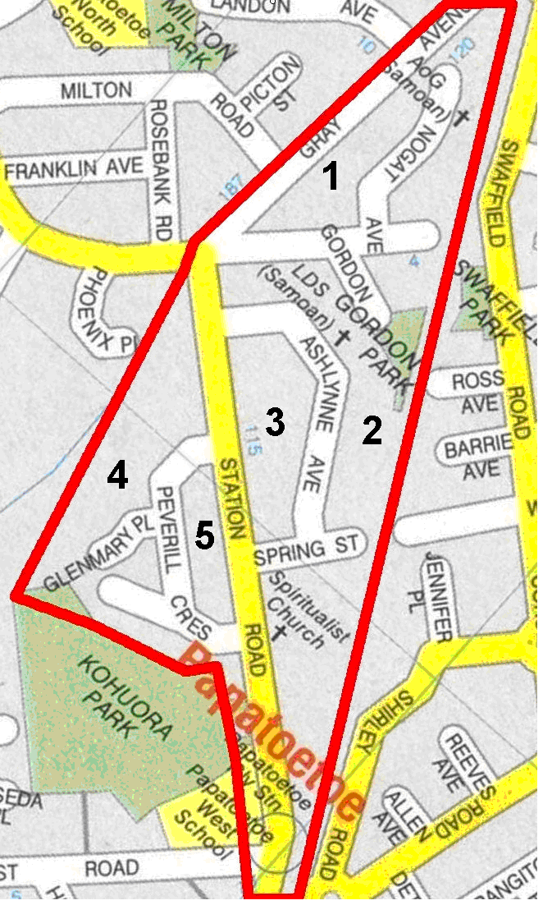

|  |  |  |  |
| --- | --- | --- | --- |
| **CALL ALL** | |  |  | | --- | --- | | **MAP** | **27** | |
| **Alabaster Drive Papatoetoe** | Printed 1/1/2014 |

**Do not call**

**Komako 6 and 8 Lendenfeld 5**

**Malte Brun 6 McDonald 24/5**

**Phoenix 10/3 Portage 150 and 170a and 210**

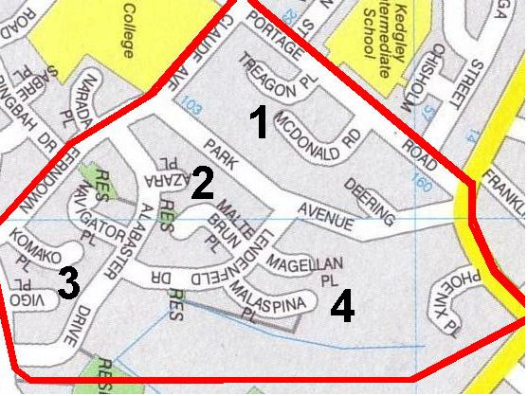

|  |  |  |  |
| --- | --- | --- | --- |
| **CALL ALL** | |  |  | | --- | --- | | **MAP** | **28** | |
| **Landon Avenue Papatoetoe** | Printed 1/1/2014 |

**Do not call**

**Buckland 44 Gray Ave 103/1 and 155b**

**Eden 20 Landon 10 and 13 and 50/1**

**Milton 44 Picton 18**

**Rosebank 25 Staines 3**

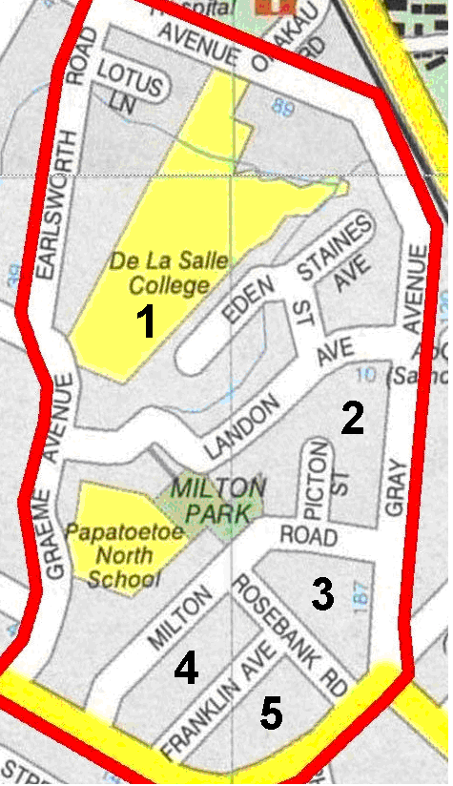

|  |  |  |  |
| --- | --- | --- | --- |
| **CALL ALL** | |  |  | | --- | --- | | **MAP** | **29** | |
| **Hokianga Papatoetoe** | Printed 1/1/2014 |

**Do not Call**

**Celia 2 Kairanga 13**

**Haddon 3a Tiari 9**

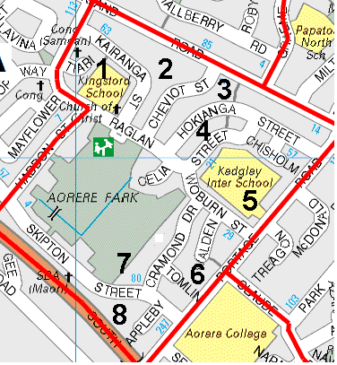

|  |  |  |  |
| --- | --- | --- | --- |
| **CALL ALL** | |  |  | | --- | --- | | **MAP** | **30** | |
| **Henwood Road Papatoetoe** | Printed 1/1/2014 |

**Do not call Henwood 15/2 caution**

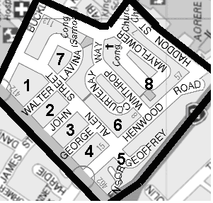

|  |  |  |  |
| --- | --- | --- | --- |
| **CALL ALL** | |  |  | | --- | --- | | **MAP** | **31** | |
| **Hillcrest Road Papatoetoe** | Printed 1/1/2014 |

**Do not call**

**Ferndown 52 Hillcrest 11d and 25a and 29 and 84**

**Hillside 1 and 67**

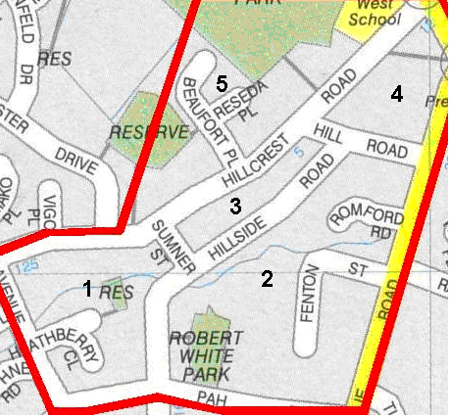

|  |  |  |  |
| --- | --- | --- | --- |
| **CALL ALL** | |  |  | | --- | --- | | **MAP** | **32** | |
| **Hillside Road South Papatoetoe** | Printed 1/1/2014 |

**Do not Call**

**Margaret 7/2 and 25b Pah Road 76/1**

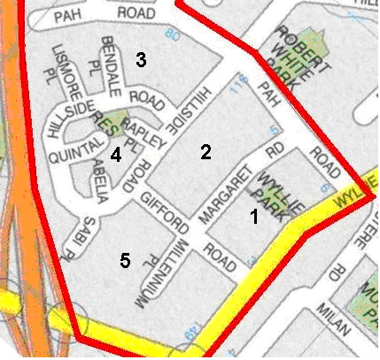

|  |  |  |  |
| --- | --- | --- | --- |
| **CALL ALL** | |  |  | | --- | --- | | **MAP** | **33** | |
| **Lenore Road Mangere** | Printed 1/1/2014 |

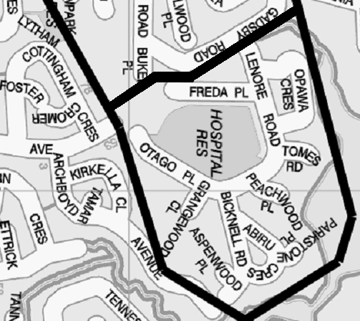

|  |  |  |  |
| --- | --- | --- | --- |
| **CALL ALL** | |  |  | | --- | --- | | **MAP** | **34** | |
| **Garus Avenue Mangere** | Printed 1/1/2014 |

